Tool: Errors and Mitigation
Define a Hypothesis

Instructions:
Use this tool to help you recognize and mitigate errors in hypothesis testing. The first page is a summary of the error types, their relationship to the null hypothesis, and generic mitigation strategies. The second page is a worksheet in which you analyze the risk of Type I and Type II errors for your specific research question.

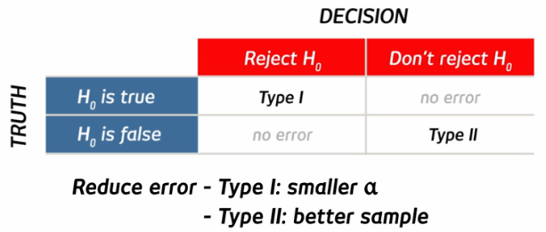

Risk mitigation process

Step 1: Record your null and alternative hypotheses.
H₀:
H_{a}:
Step 2: Complete the table by filling in the downside risk of the false positive and false negative errors, and indicating what alpha (critical p-value) you’ll choose and what measures you might take to mitigate Type II error.

Error Mitigation
Error Type | Downside / risk of this error | Current parameters
Type I (false positive) | (e.g. H₀ is that a market does not exist. Ha is that a market does exist. Risk is that we may conclude from our experiment that a market exists when for our product when it doesn’t.) | (record your alpha here)  α =
Type II (false negative) | (e.g. H₀ is a potential client is not a good lead. Ha is that they are a good lead. Risk is that we may omit a large number of potential clients from a contact list despite the fact that they are good leads.) | (indicate how you will mitigate Type II errors here)

